A **control system** is an arrangement of different physical elements connected in such a manner as to direct, regulate or command itself or another system

Based on feedback, control systems are classified into following two types, viz

* Open Loop Control System
* Closed Loop Control System

An **open loop control system** is the one in which the output signal is not fed back to the input of the system. Therefore, an open loop control system is also referred to as a non-feedback control system.

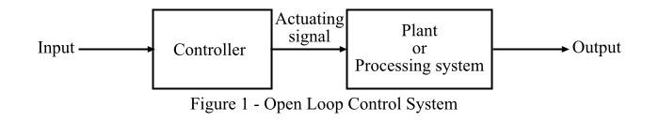

In case of open loop control system, the output has no control on the control action of the system. Thus, the open loop control system follows its input signals regardless of the final results. The block diagram of the open loop control system is shown in Figure-1. Here, the main components are: controller and plant (or processing system). The input is supplied to the controller which produces an actuating signal (or control signal). This actuating single is supplied to the plant or processing system which is to be controlled.

The major disadvantage of an open loop control system is that it is poorly equipped to handle the disturbances which may reduce its ability to complete the desired task.

Some common examples of open loop control system are: TV remote,( A TV remote is an example of open control system. When we press any button on the remote, it will send a signal to the TV and make some changes, but the remote not getting any signal from the TV whether any changes happens or not.) Traffic light system, Field controlled DC motor, Automatic washing machine, immersion rod,

A **closed loop control system** is the one in which the output signal is fed-back to the input of the system. Therefore, in a closed loop control system, the control action is a function of desired output signal.

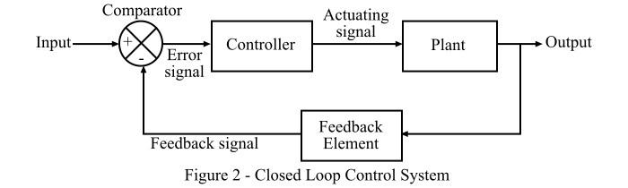

The main components of a closed loop control system are − controller, plant, error detector or comparator and feedback element which are connected together as shown in Figure-2. The error detector accepts input sinal and feedback signal to produce an error signal which is the difference of input and feedback signals. The feedback signal is the sample of output of the overall system.

Now, the error signal is supplied to the controller to produce an actuating signal which controls the plant or processing system to produce desired results. Therefore, in the closed loop control system, the input of the system is automatically adjusted to produce a desired response from the system. The common examples of closed loop control system are − air conditioner system, rocket laungching system, radar tracking system, human respiratory system, etc.

The following table highlights the major differences between open loop control system and closed loop control system

| **Basis of Difference** | **Open Loop Control System** | **Closed Loop Control System** |
| --- | --- | --- |
| Feedback | A control system in which there is no feedback path is provided is called an *open loop control system.* | The control system in which there is a feedback path present is called a *closed loop control system*. |
| Main Components | The major components of an open loop control system are − controller and plant. | The main components of a closed loop control system are − Controller, plant or process, feedback element and error detector (comparator). |
| Design complexity | The design and construction of an open loop control system is quite simple. | Closed loop control system has comparatively complex design and construction. |
| Response | Open loop control system has fast response because there is no measurement and feedback of output. | The response of the closed loop control system is slow due to presence of feedback. |
| Reliability | The reliability of open loop control system is less. | The closed loop control system is more reliable. |
| Accuracy | The accuracy of open loop control system depends upon the system calibration and therefore, may be less. | Closed loop control system is comparatively accurate because the feedback maintains its accuracy. |
| Stability (in terms of output) | The stability of open loop control system is more, i.e., the output of the open loop system remains constant. | Closed loop control system is comparatively less stable. |
| Optimization | The open loop control system is not optimized. | Closed loop control system is optimized to produce the desired output. |
| Maintenance | Open loop control system requires less maintenance. | Comparatively more maintenance is needed in closed loop control system. |
| Implementation | Open loop control system is easy to implement. | The implementation of a closed loop control system is relatively difficult. |
| Cost | Open loop control system is less expensive. | The cost of the closed loop control system is relatively high. |
| Noise | Open loop control system has more internal noise. | In closed loop system, the internal noise in the system is less. |
| Examples | Common practical examples of open loop control systems are –TV remote, automatic traffic light system, automatic washing machine, immersion heater, etc. | Examples of closed loop control systems include: , Automatic RoomTemperature controller, Voltage stabilizer, rocket launching system, radar tracking system, etc. |

.